VÀ TRUYỀN THÔNG VIỆT - HÀN
KHOA KHOA HỌC MÁY TÍNH


MIDTERM PROJECT REPORT

MOBILE APPLICATION FOR MANAGING STORE TIME (Fashion Shop)

Student implementation : Huỳnh Diệp - 24IT039
Lê Hải Đăng - 24ITB241
Dương Mai Phương - 24IT213 Nguyễn Trần Yến Nhi - 24IT195

Supervising Lecturer : TS. Nguyễn Thanh Tuấn

Đà Nẵng, tháng 5 năm 2026

VÀ TRUYỀN THÔNG VIỆT - HÀN
KHOA KHOA HỌC MÁY TÍNH


MIDTERM PROJECT REPORT

MOBILE APPLICATION FOR MANAGING STORE TIME (Fashion Shop)

Student implementation : Huỳnh Diệp - 24IT039
Lê Hải Đăng - 24ITB241
Dương Mai Phương - 24IT213 Nguyễn Trần Yến Nhi - 24IT195

Supervising Lecturer : TS. Nguyễn Thanh Tuấn

Đà Nẵng, tháng 5 năm 2026

PROJECT INFORMATION

Field | Detail
Project Title | Fashion Shop Mobile Application
Course | Software Engineering
Team Name | Team 9
University | Vietnam-Korea University of Information and Communication Technology (VKU)
- TEAM MEMBERS & RESPONSIBILITIES

No | Student ID | Full Name | Role
1 | 24IT039 | Huỳnh Diệp | Scrum Master / Lead Developer
2 | 24ITB241 | Lê Hải Đăng | UI/UX Developer
3 | 24IT213 | Dương Mai Phương | Backend & Firebase Developer
4 | 24IT195 | Nguyễn Trần Yến Nhi | Tester & Documentation

Specific Responsibilities:

➔ Huỳnh Diệp: Sprint planning, task coordination, implementing core navigation, and state management.
➔ Lê Hải Đăng: Designing and implementing all UI screens (Home, Detail, Cart, Favorites, Profile).
➔ Dương Mai Phương: Integrating Firebase Firestore, handling authentication logic, and real-time data synchronization.
➔ Nguyễn Trần Yến Nhi: Writing test cases, performing manual testing, and preparing project documentation/demo video.

INTRODUCTION

Project Overview
This project focuses on developing the Fashion Shop Mobile Application for Android using Jetpack Compose and Firebase Firestore. The application provides a seamless online shopping experience for customers and a comprehensive management tool for administrators.

Objectives
      - Develop a fully functional Android e-commerce prototype.
      - Apply Agile (Scrum) methodology to the software development lifecycle.
      - Implement core features: User authentication, shopping cart, order management, and product reviews.

Methodology
      - The team follows the Scrum model, divided into three 2-week Sprints.

Tool | Purpose
GitHub | Source code management and version control
Trello | Task management and Sprint backlog
Figma | UI/UX design and wireframing
Firebase | Cloud database and real-time monitoring
Android Studio | Primary Development Environment (IDE)

SYSTEM REQUIREMENTS

Functional Requirements (FR)
      - FR1: User Registration and Secure Login.
      - FR5: Browse products by category (All, Tops, Bottoms, Dresses).
      - FR8: Add products to cart with size selection.
      - FR11: Place orders with delivery address input.
      - FR17: Star ratings (1-5) and text reviews for products.
      - FR20: Admin: Manage products (CRUD) and inventory levels.
      - FR21: Admin: Update order status through 7 stages.

Non-Functional Requirements (NFR)
      - Performance: Interaction response time within 2 seconds.
      - Availability: Real-time data synchronization via Firebase.
      - Design: UI follows Material Design 3 standards.

SYSTEM DESIGN (C4 MODEL)
    - System Context Diagram
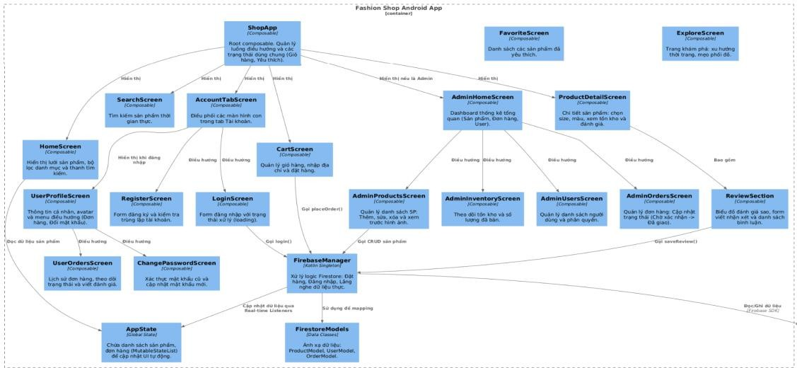

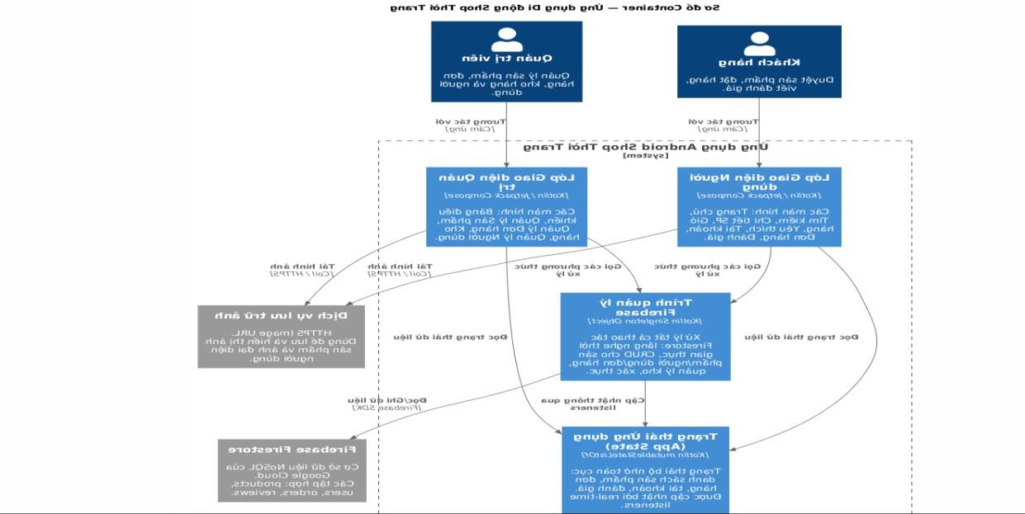

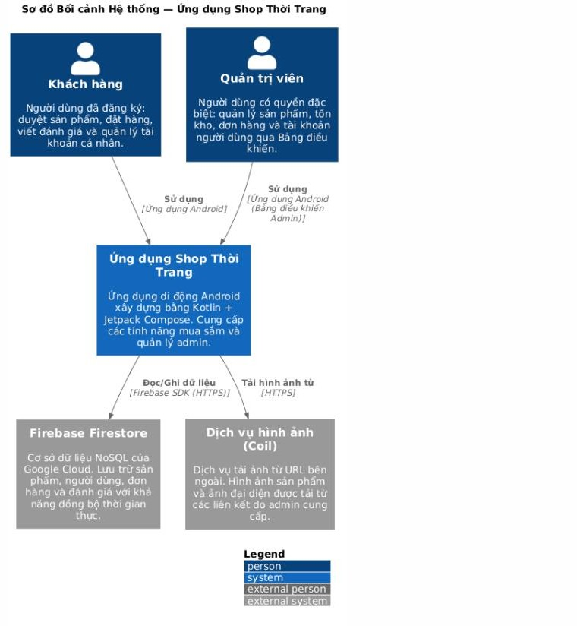

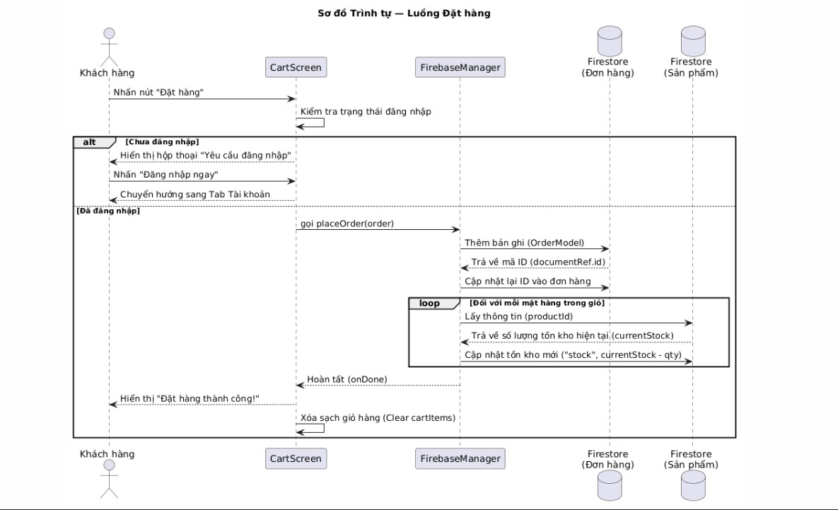

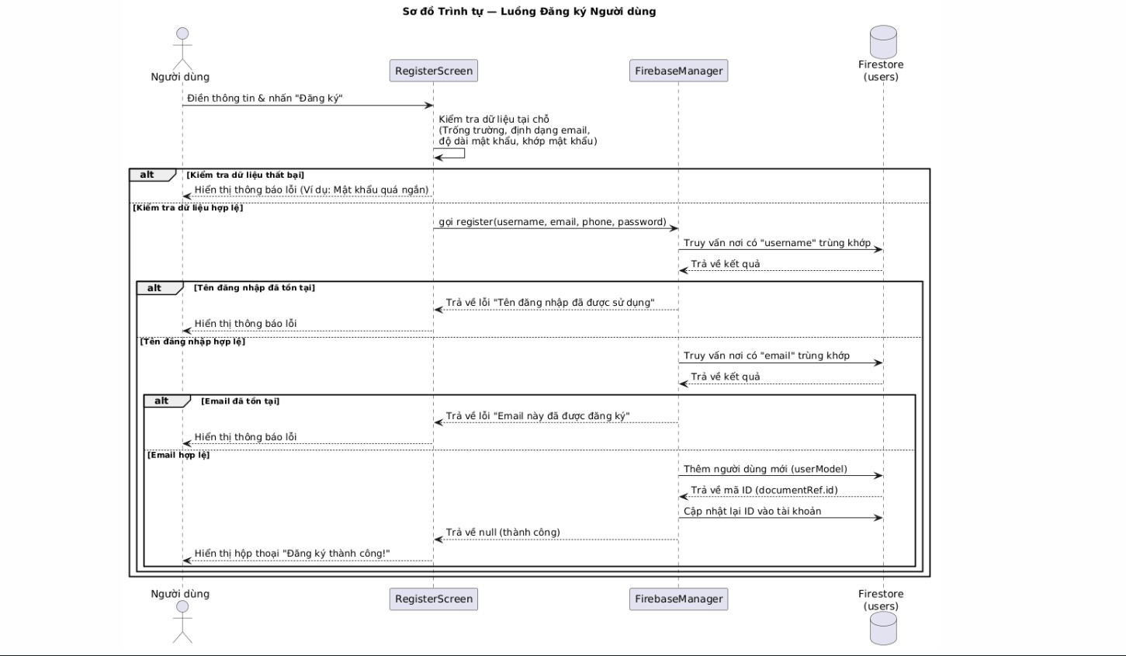

DEVELOPMENT

Technology Stack
      - Language: Kotlin.
      - UI Framework: Jetpack Compose (Material Design 3).
      - Database: Firebase Firestore (NoSQL).
      - Image Loading: Coil Library.

Sprint Progress
      - Sprint 1: Project setup, Firebase integration, Auth module, Product listing.
      - Sprint 2: Shopping cart, Order placement, Admin dashboard, and Inventory.
      - Sprint 3: User profiles, Product reviews, Order history, and UI polishing.

TESTING

Test ID | Feature | Input | Expected Result | Status
TC1 | Register | Valid info | Account created successfully | ⬛ Pass
TC6 | Admin Login | Admin credentials | Redirect to Admin Panel | ⬛ Pass
TC9 | Place Order | Logged-in user | Order created; stock updated | ⬛ Pass

Test ID | Feature | Input | Expected Result | Status
TC12 | Out of Stock | Stock = 0 | "Out of stock" badge displayed | ⬛ Pass
  - DEPLOYMENT & DEMO
- Firebase Project ID: dacs3-d4e36
- GitHub Repository: https://github.com/dh006/DOAN3.1
- Demo Video: https://drive.google.com/file/d/1bbEUozFBZ-1VxVE3lrBD3y-MpMc_dAJC/view?usp=sharing

CONCLUSION
The project successfully met its objectives, delivering a stable fashion e-commerce application with real-time data capabilities. The team effectively applied Scrum methodology and modern Android technologies. Future enhancements will include online payment integration and Push Notifications.

REFERENCES
- Android Developers. Jetpack Compose Documentation.
- Google Firebase. Cloud Firestore Documentation.
- Material Design. Material Design 3 Guidelines.

